Some of the important activities carried out by Nature Club- EASY (Environment Awareness by Sensitising the Youth) from 2012 academic year
(Apart from the regular activities of making the campus greener by planting more trees and cleaning the campus)
10/07/2012
The students were given awareness regarding protecting the nature and natural resources.
27/08/2012
Took initiative in making the campus plastic free.
1/9/2012
The Club engaged in activities to make the campus green by planting saplings issued by the Department of Forest, Govt of Kerala (through proper channel).
20/12/2012
Nature club felicitated and honored Padmasri Sri. Shankar (Habitat).
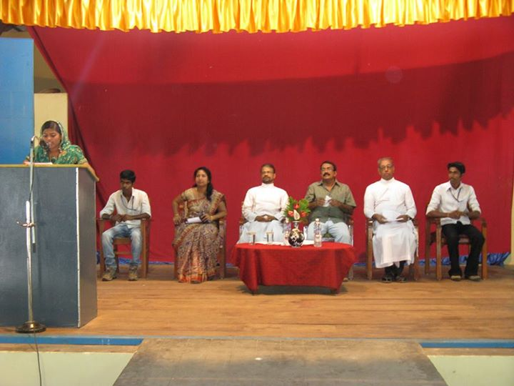

27/12/2012
Presentation cum demonstration was arranged on mushroom cultivation, in collaboration with the Women’s Study Centre. Smt. S.Janaky was the resource person, (a member of the Scientific Advisory Board, K.V.K. Mitranikethan).
29/12/2012 (one month long procedure)
The members of the Nature club did mushroom cultivation on experimental basis using the spawn provided by Smt. Janaki and edible fruiting bodies should be produced effectively.
15/1/2013
The Club conducted a series of seminars under the name “Inter Departmental Collaborative programme” incorporating teachers of different Departments of our college. Dr. Harish(Department of Botany and Biotechnology), Dr. Zajo Joseph (Professor, Dept of Commerce and Joint convener of Nature Club), Sri. Thomas P. John (Dept of History), Dr. George Thomas (Dept of Physical education) etc. are some of the eminent teachers who took seminars on various topics related to Environment and allied topics.
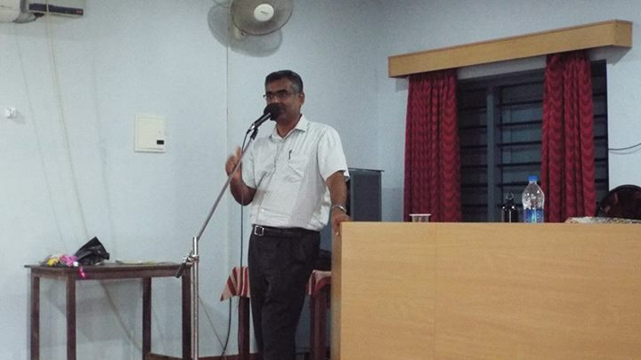

5/6/2013-
Observed world environment day. Entire students of the college took an Environment oath prepared and circulated by the Club. Prof. Reghuvaran Nair took a seminar on importance of plants. Principal chaired the program

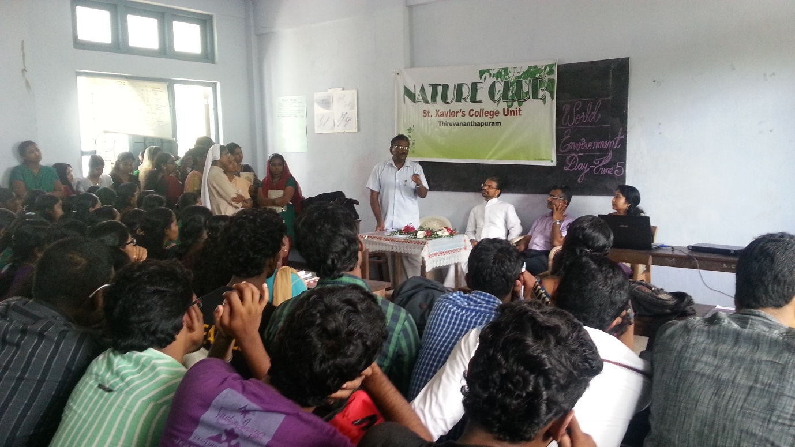

1/7/2013
Naming of campus flora- Club started a major work on naming the important trees present in the campus. With the help of experts in the field of Plant Taxonomy, name boards were hung on campus trees writing scientific names and families. (2 months duration procedure)

30/10/2013
A quiz on wildlife and nature was conducted. Quiz master was Sri Burney Sebastian, Professor, Dept. of Economics. Cash prizes and certificates distributed by the Principal, Rev.Fr. Dr. Sunny Jose S.J. 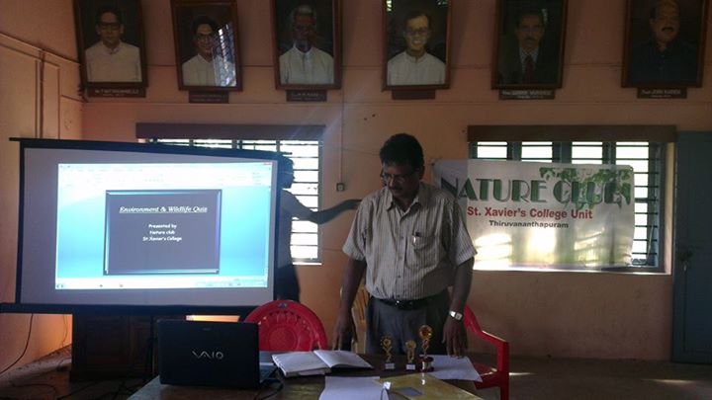

23/2/2014
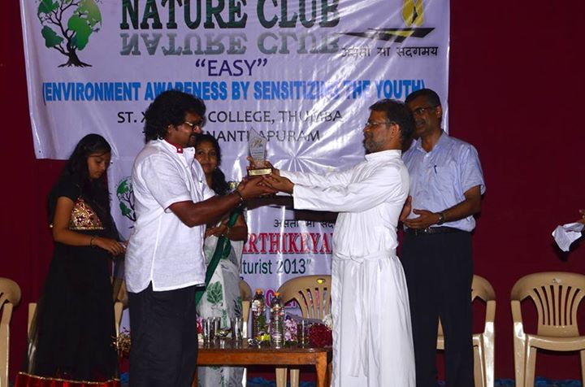
Club observed Science day on 28th of February, 2014 on which occasion Sri. VinooKarthikeyan, winner of State Govt.’s best Horticulturist award, 2014 was felicitated by the respected Principal of our college, Rev. Fr. Sunny Jose S.J.

23/2/2014
Paper presentation by AneeshaAni Benedict of the Dept. of Botany and Biotechnology on marine life.
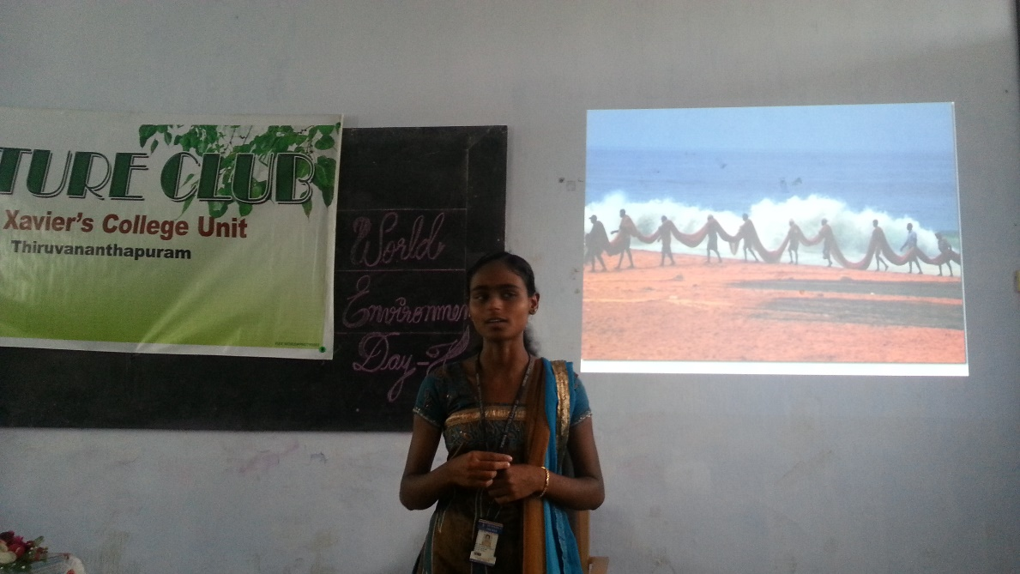

4/6/2014
A ‘flash mob’ was conducted by the students of Nature Club about the importance of protecting the nature and an awareness campaign was also done connected with the flash mob giving messages regarding need of conservation of nature, energy etc.

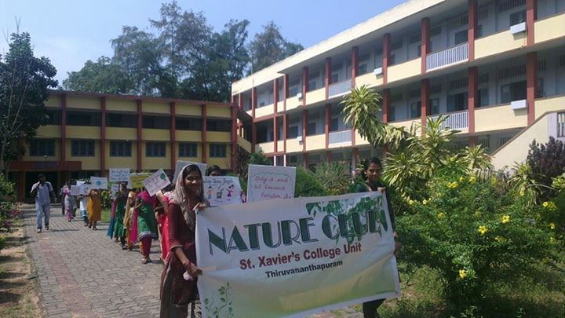
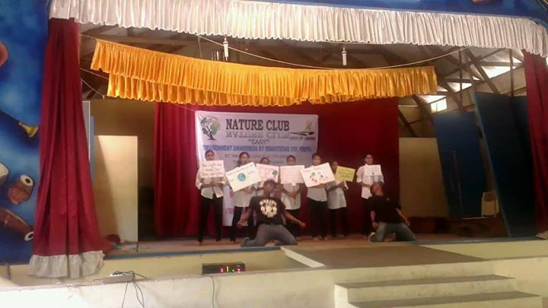

5/6/2014-
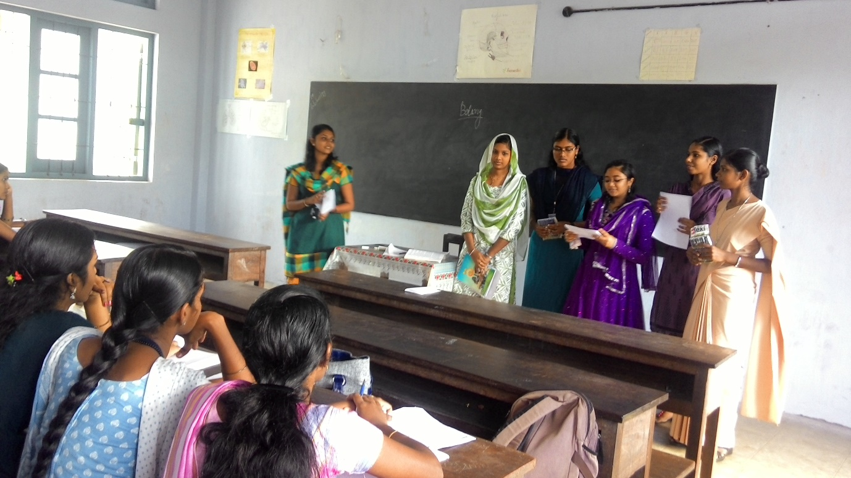
Students of Nature Club conducted a class wise environment awareness campaign and also conducted a short quiz on Nature. Prizes were distributed on the spot to the winners.

19/8/2014
Observed World photography day by conducting a seminar on wild life photography by Dr. Nisha Rani D., Convener, Nature Club

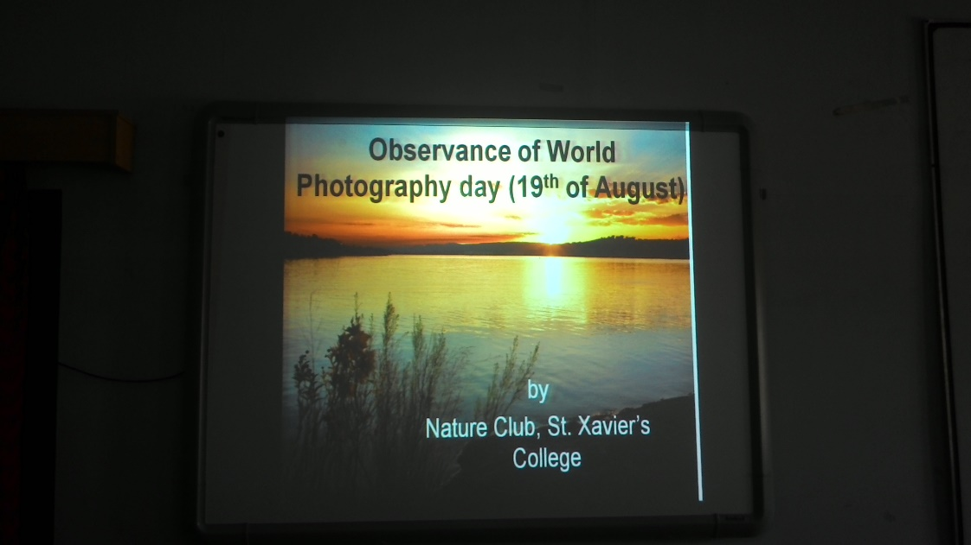
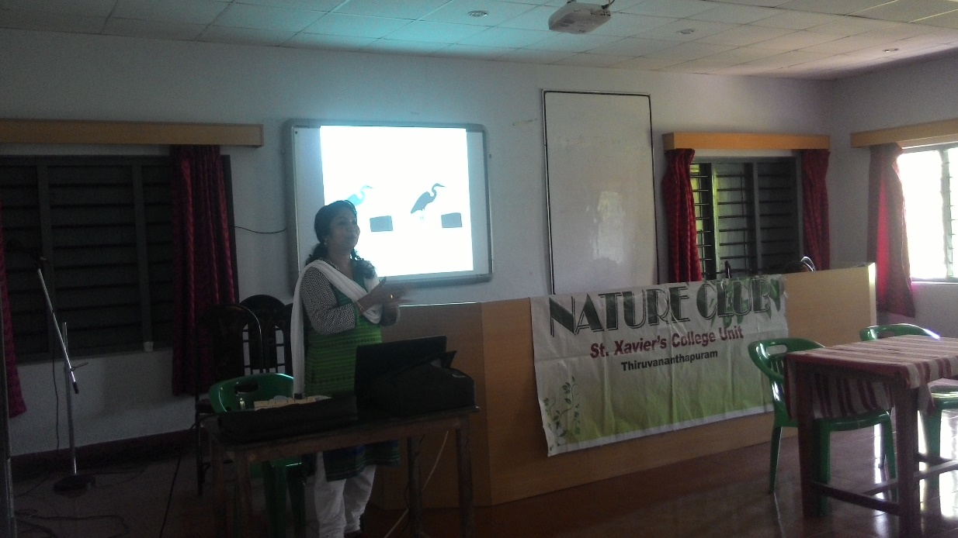

29/8/2014
Plastic free campaign launched which was flagged off by the Principal, Rev. Fr. Dr. Sunny Jose S.J.
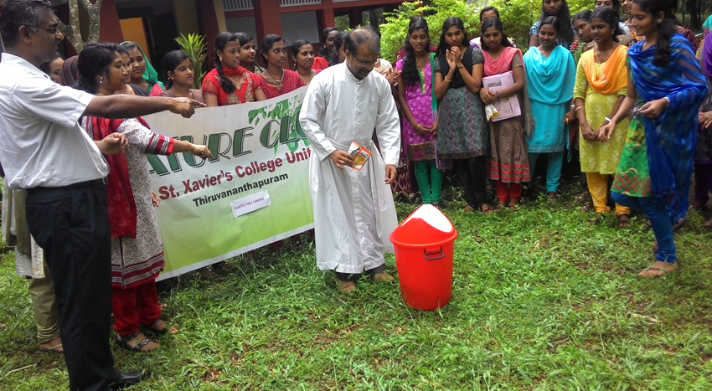

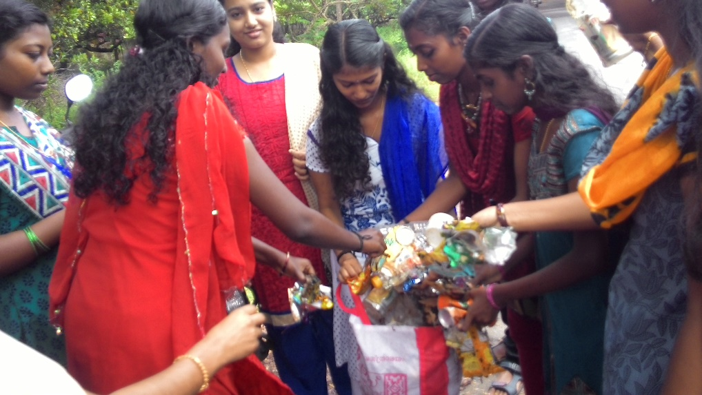
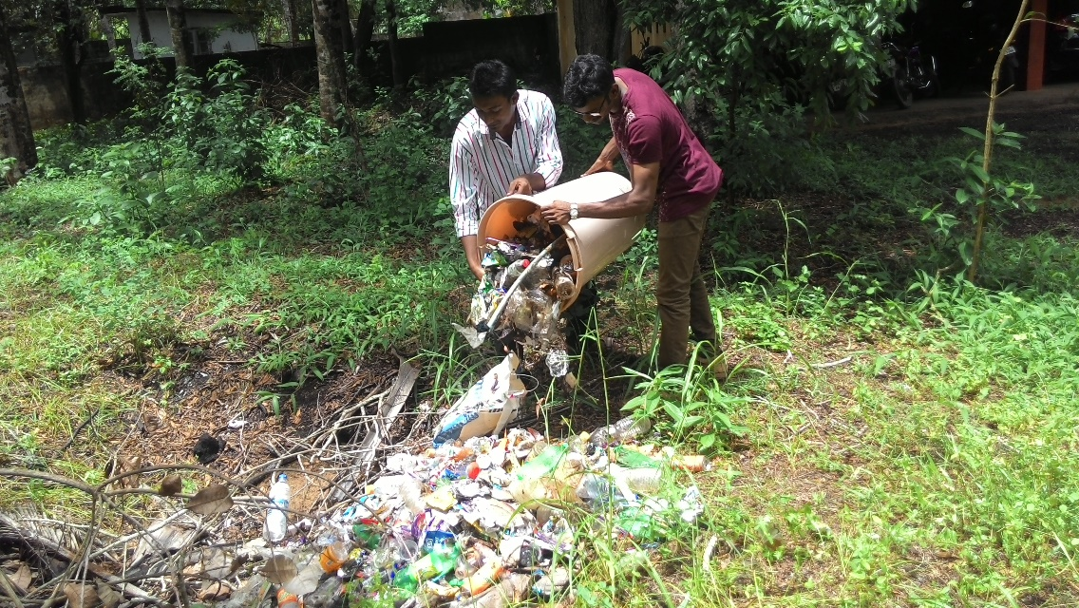

1/9/2014
Some members have taken a small documentary on pollution in 'Parvathyputhanar' as a part of giving awareness to the society regarding pollution of water bodies.

7/10/2014
Vegetable cultivation started by the members inside the Botanical garden.
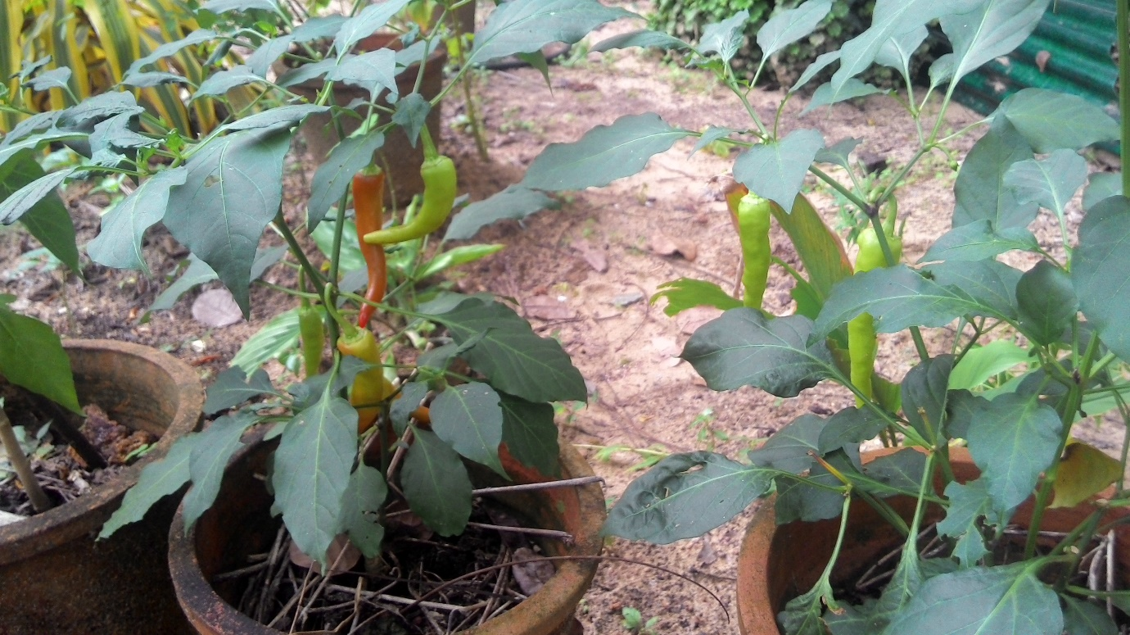

20/11/2014S
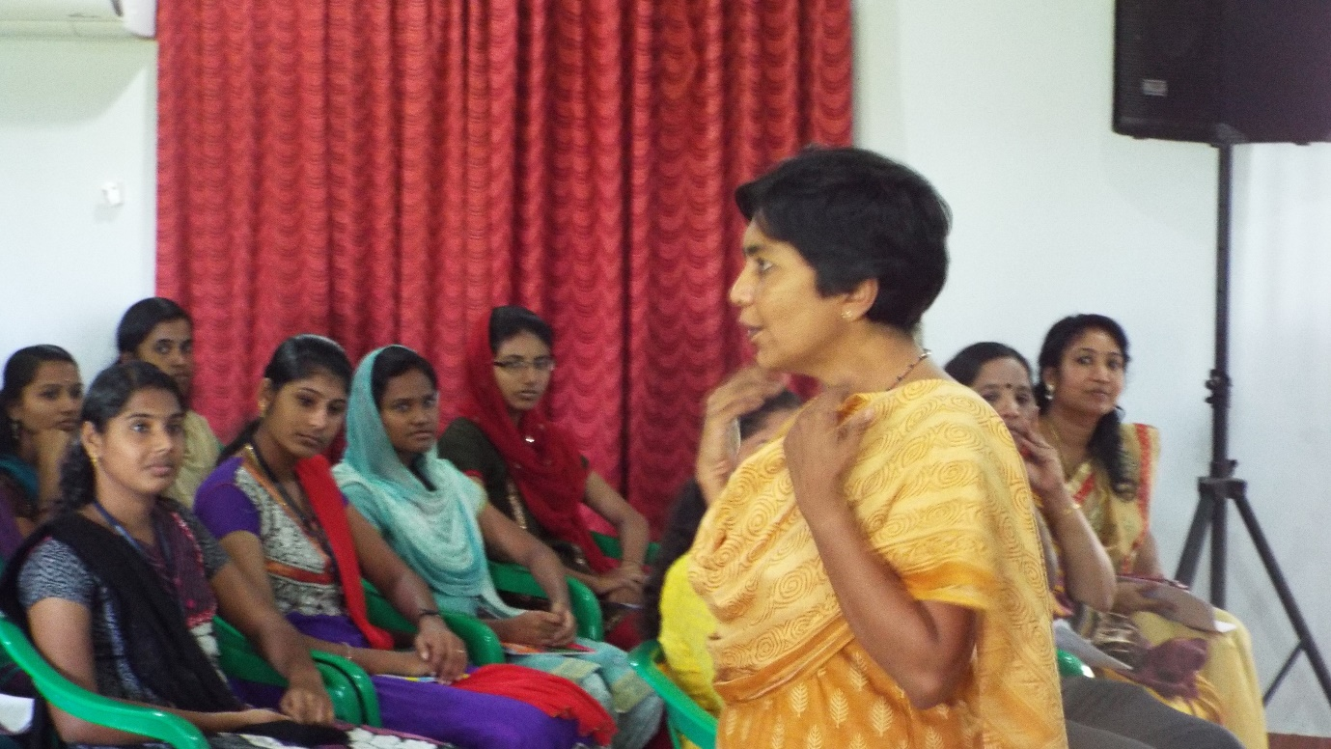
Seminar by a young Environmentalist, Smt. Veena, member, Thansal, Thiruvananthapuram on ‘Conservation of Nature’.

21/11/2014
Observed World fisheries day. Former Nature club member, Miss. Aneesha Annie Bennedict conducted a book review on ‘Ormathirakal’, written by Dr. Paul Thomas, a fisherman turned Professor.
20/2/2015
Documentary prepared and presented by the members on ‘the successful story of a farmer’ to motivate the students in farming.

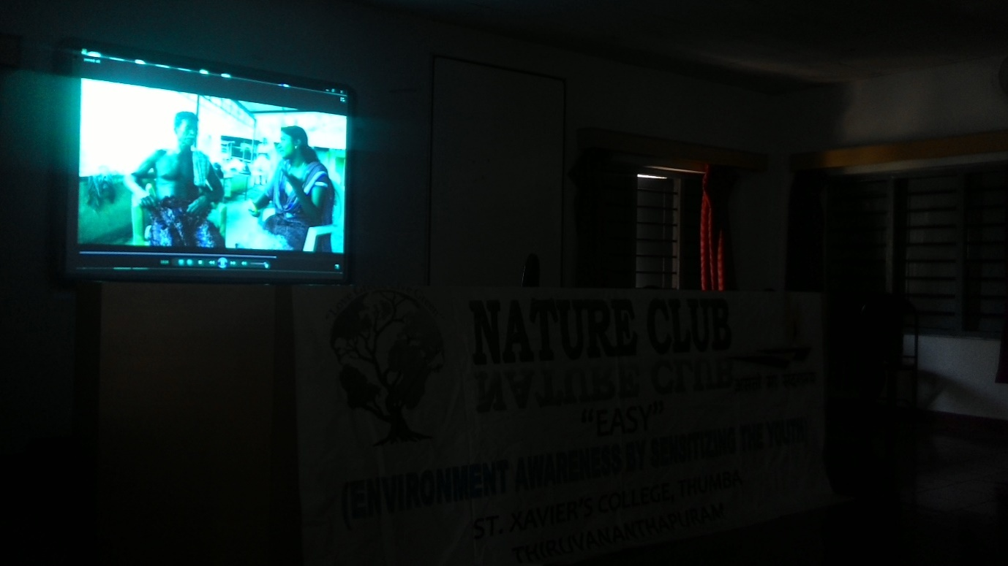
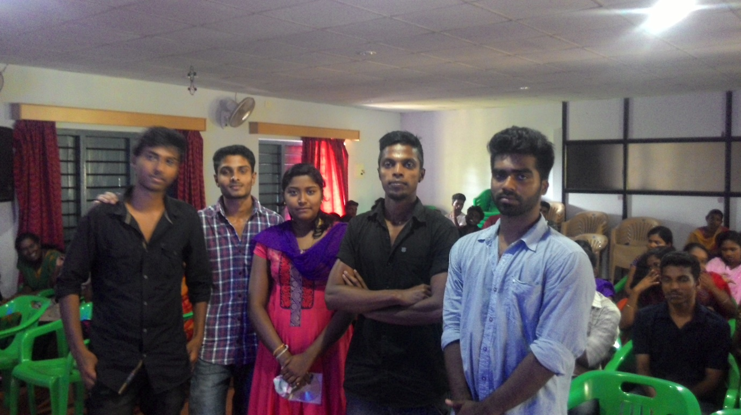
Members behind the documentary
From the documentary

19/3/2015
Major project of the year is participation of Nature club members in a global greening competition conducted by the green wing of Infosys, named ‘Aagaaz’. Two month duration work started by our members on 19/3/2015. The work proposed was "Unravelling the beauty of an unfathomed campus spot" under which our students cleaned a pond inside the campus and beautified its surroundings and has made the same into a beautiful resting spot. Work still goes on to maintain it as such and plan to preserve it permanently.

5/6/2015.
Observed World environment day by conducting a campus walk from the college office to the pond cleaned and beautified by the Nature club members, (leader of the team- Anith of the Dept of History). The team consisted of more than 10 teachers,non-teaching staff and nature club student members led by the Principal, Rev. Fr. Sunny Jose S.J. Principal appreciated the students behind the pond cleaning. The current President, Anith, who was also the leader of the pond cleaning group addressed the gathering and mentioned about the competition they took part during vacation conducted by ‘Aagaaz’, a nature loving wing of Infosys.
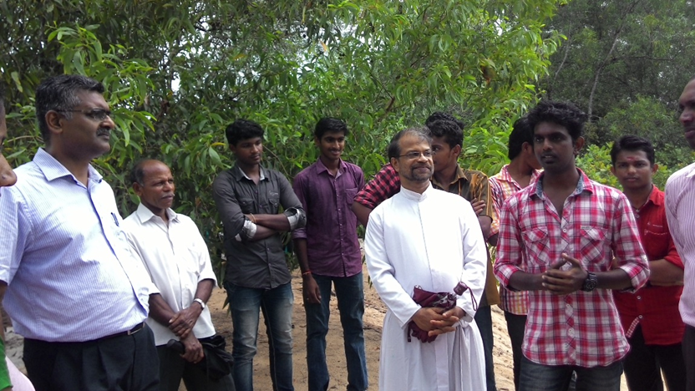
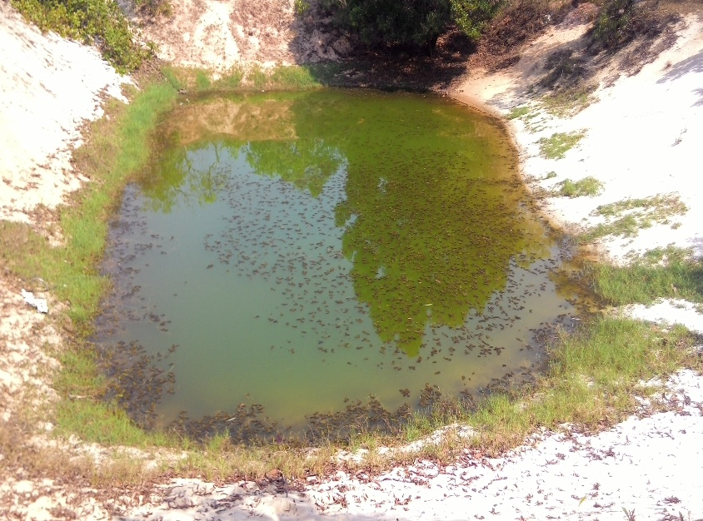
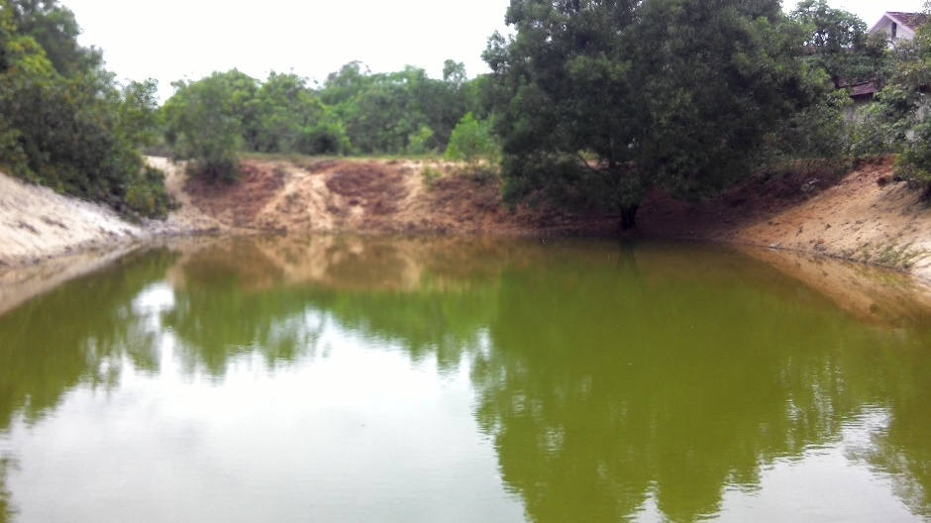
Before cleaning
After cleaning

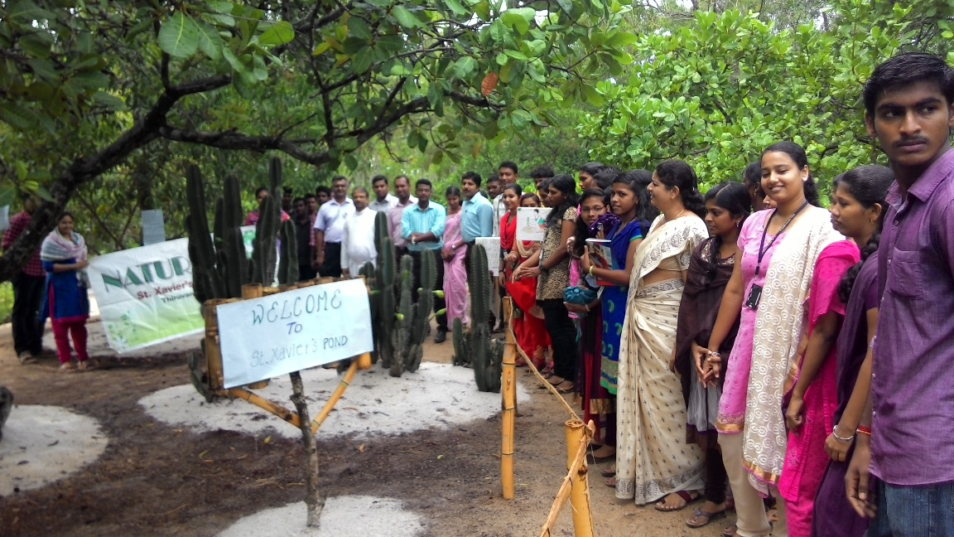

On the same day, Nature Club members joined the ‘Neem green Kerala’, a group of environmentalists (retired professors) in planting 25 neem tree saplings in the campus.
